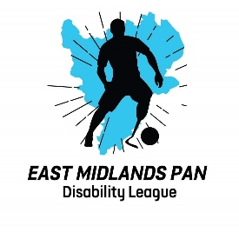

DATE: Jan 2026
REVIEW: Jan 2027

MEDICAL EMERGENCY ACTION PLAN

League Name: East Midlands PAN Disability League
League Home Address: Gresham Park, West Bridgford, NG2 7YF
Telephone: Gresham Park – 0115 9148553

FIRST AIDERS / HELPER INFORMATION
in the first instance, see your team coach for first aid on the day of the match

Name/Mobile Number: Lincoln Christer, League Secretary 07493 153187
Martin Dellar, DSO 07806 557576
Steve Douglas, Deputy DSO 07545388439
Darren Bailey, League Chairman 07789 817481

For queries about this EAP: Lincoln Christer – League Secretary

FIRST AID EQUIPMENT AND FACILITIES
Defibrillator: Outside double doors of main reception – site staff have code

First Aid Room: Inside main reception

ACCESS ROUTES
For Ambulance: Through main gate, around the back of the main carpark onto the field adjacent to the pitches

Air Ambulance: Field next to the pitches

OTHER INFORMATION
In the first instance, ring 999/112 – National Emergency Response Service

Nearest Accident & Emergency: Queens Medical Centre (QMC) – 0115 9240024
From Gresham Park, at roundabout take 2nd exit onto Gresham Park Rd
At roundabout take 2nd exit onto Wilford Lane B679
At roundabout take 1st exit onto A52/A453, sliproad to M1 North/Derby/QMC
Merge onto Clifton Bvd/A52
Take exit to QMC

Nearest Walk-in Centre: Urgent Treatment Centre, Seaton House, City Link, Notts, NG2 4LA

